AI-Based Military Triage System: A CNN Approach for Rapid Patient Prioritization

Vijetha
Associate Professor,
Department of Information Science and Engineering,
Dayananda Sagar College of Engineering,
Bengaluru, Karnataka, India.
vijetha-ise@dayanandasagar.edu
Mayuri J Shetty, Student,
Department of Information Science and Engineering,
Dayananda Sagar College of Engineering,
Bengaluru, Karnataka, India.
mayurishetty444@email.com
Manikya S, Student,
Department of Information Science and Engineering,
Dayananda Sagar College of Engineering,
Bengaluru, Karnataka, India.
manikyashivanandappa@gmail.com

Mohammed Iqbal Nawab, Student,
Department of Information Science and Engineering,
Dayananda Sagar College of Engineering,
Bengaluru, Karnataka, India.
fabb.nawab@gmail.com

Pranathi A, Student,
Department of Information Science and Engineering,
Dayananda Sagar College of Engineering,
Bengaluru, Karnataka, India.
pranathi.ananth@gmail.com

Abstract—Battlefield triage comes down to a numbers problem: more patients than personnel, and no internet to fall back on. Under those conditions, manual assessment is both slow and unreliable. This paper presents a triage decision support system built on a Convolutional Neural Network that sorts patients into critical, moderate, and stable categories based on vital signs, reported symptoms, and injury data. The system runs entirely on local hardware, stores records in SQLite through a Python backend, and displays results on a React based Doctor Dashboard showing alerts and case summaries rather than raw scores. Tests on a simulated emergency dataset confirm the CNN holds up when inputs are noisy or missing fields. The codebase is intentionally lean, and swapping in PostgreSQL or adding cloud sync requires minimal rework once a network becomes available.
Keywords: Military triage, Convolutional Neural Networks, emergency healthcare, decision support systems, offline AI, patient prioritization, deep learning, medical classification

- Introduction

This paper describes a triage system built for medical environments where time pressure is constant and mistakes are costly. At its core, the system pairs a CNN severity classifier with a Python backend, React frontend, and SQLite database. No internet connection is required, and that constraint shapes nearly every architectural decision made throughout the build. A Doctor Dashboard sits on top of the model, turning raw predictions into something useful: a prioritized patient list, alerts for critical cases, and concise case summaries. The stated goal is narrow but consequential cut the time between a patient arriving and a treatment decision being made.
In emergency and battlefield settings, triage falls to whoever is present. That means outcomes vary based on availability, experience level, and how many hours that person has already been on their feet. As casualty load builds over time, consistency degrades and errors accumulate. Cloud based AI tools offer no solution here because the connectivity they depend on is exactly what field environments cannot guarantee. There is a real and largely unaddressed gap between what AI systems can do inside a well resourced data center and what they can actually deliver in a forward operating base or disaster site. This paper works within that gap rather than assuming it away.
Three concrete outcomes drive the design. The classifier needs to handle noisy, incomplete patient records and still produce severity labels that medical staff can act on. The system needs to run fully offline, with real time inference and persistent local storage that does not depend on any external service. And the dashboard needs to lower the cognitive load on personnel who are already operating under pressure, not introduce another interface that demands interpretation.

Survey of Related Work

Smith and Lee [1] showed that ML based triage outperforms rule based approaches on vital sign classification, with measurable reductions in decision time. Johnson et al. [2] applied CNNs directly to patient severity classification in emergency departments and found they identified high risk patients faster than existing protocols. Wang and Zhang [3] integrated structured medical data with neural networks and reported improved outcome prediction, particularly during high patient inflow periods. Brown et al. [4] combined real time monitoring with predictive analytics in a decision support system, with consistency across practitioners as the primary concern. Kumar and Patel [5] demonstrated that lightweight ML models can function without continuous connectivity, a finding that directly informs several design choices made in this paper. Chen et al. [6] added recurrent layers to a CNN to capture historical patient trends alongside current status, which improved classification on cases where condition trajectory mattered as much as current readings. Garcia and Fernandez [7] showed that structured dashboard interfaces reduce cognitive load in time critical scenarios, supporting the interface approach taken here. Li et al. [8] examined AI triage during mass casualty incidents and documented concrete improvements in resource allocation and response time. Ahmed and Khan [9] built a symptom driven classifier designed for use by operators without formal medical training, which is relevant to deployments where specialists are unavailable. Singh et al. [10] proposed a triage architecture that spans cloud and edge computing, preserving real time decision making regardless of whether a network connection exists.

II. METHODS
- Research Question
How can combining wound images, vital signs, voice recordings, and written observations through an AI system help medics make faster and more accurate triage calls on the battlefield compared to doing it manually?
- Design

The system is built as a practical platform for two distinct users: field medics working under fire and command doctors monitoring cases remotely. The React frontend lets a medic upload a wound image, record a voice note, enter vitals, and add a short text observation in a matter of seconds. FastAPI handles everything on the backend, routing each input to its corresponding model and merging the outputs into a single triage decision. The interface asks for as little effort as possible from the user because in the target environment, every second spent on data entry is a second not spent on the patient.
The core design choice is data fusion rather than parallel processing. Vitals carry the most weight since they reflect actual physiological state; images, audio, and text fill in the picture. The system also runs real time updates, GPS tracking, and a doctor dashboard so that command has visibility without waiting for radio reports. Speed, clarity, and low friction under stress are the design priorities throughout.
The architecture is a straightforward three layer stack. The React frontend handles input collection. The FastAPI backend receives that data, coordinates model inference, and returns results. The AI layer processes each modality and produces a fused severity output. Each layer has one job, which keeps the system easy to debug and extend.

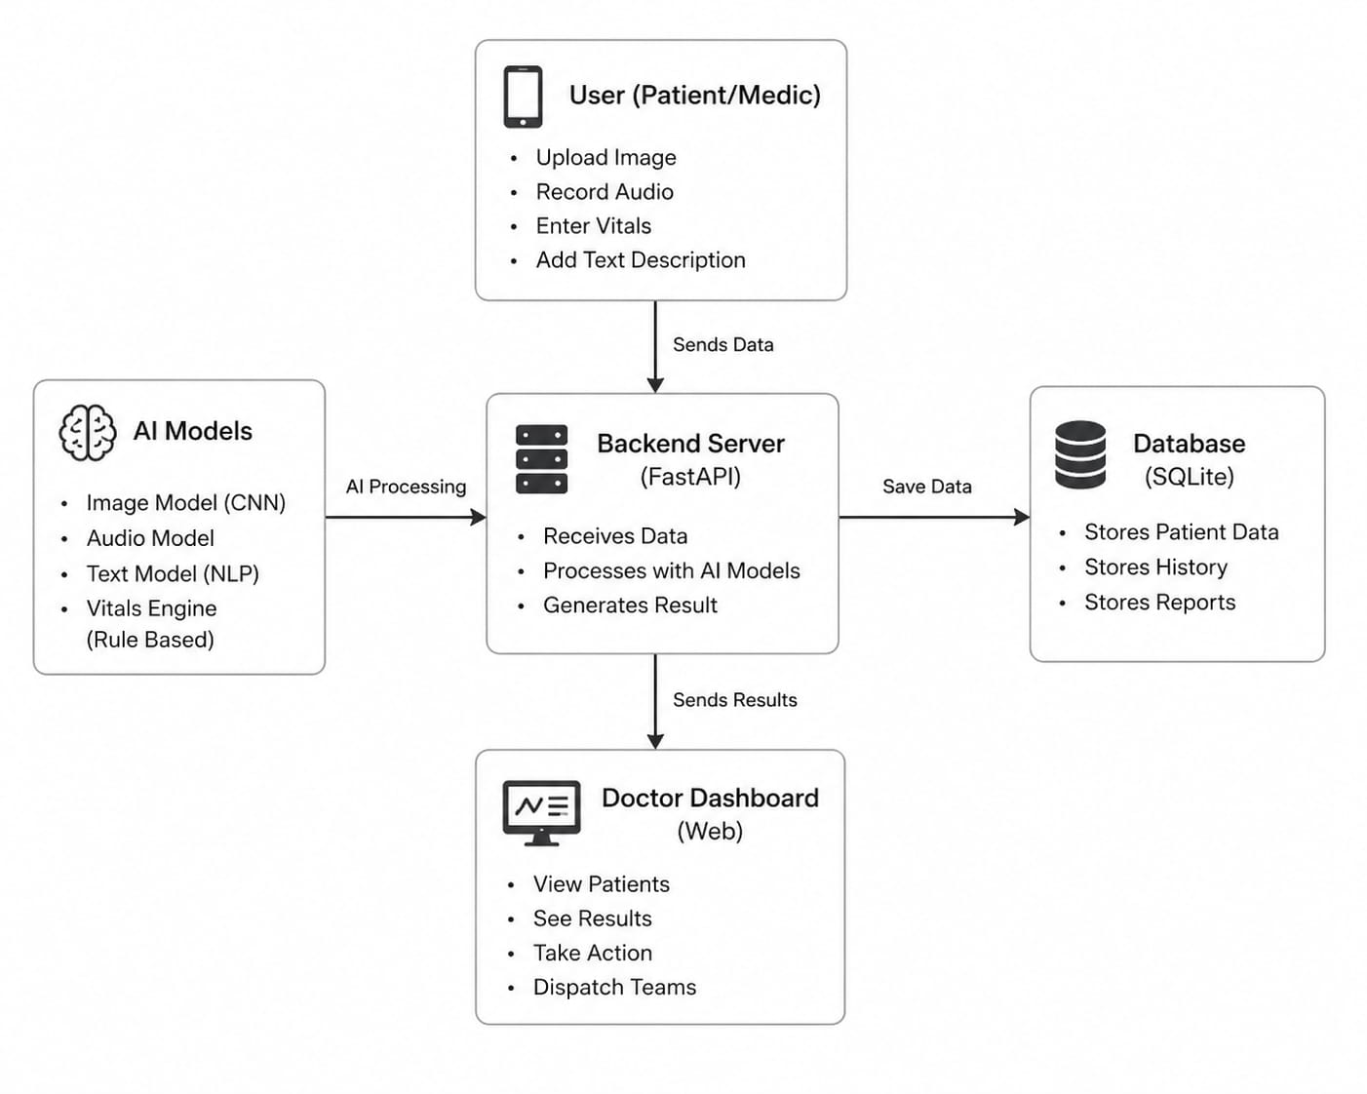
Fig 2.1 Implementation

Existing Approaches
Data Reliance: Traditional triage runs on direct observation by trained personnel present at the scene. Standard ML systems learn from historical data but need clean inputs and live connectivity to perform well. This system handles incomplete and noisy records through preprocessing and runs without a network connection.
Decision Accuracy and Consistency: Manual triage output varies with operator experience and fatigue. Rule based systems fail when real cases fall outside their defined thresholds. The CNN learns from data rather than hand coded rules, so its output stays consistent regardless of who is running it or for how long.
Response Time and Efficiency: Traditional prioritization slows under mass casualty load. Cloud AI solves throughput but requires connectivity that field environments cannot provide. Local inference means classification latency stays flat whether or not a network is present.
Noise and Uncertainty Handling: Incomplete records are routine in emergency medicine. The preprocessing pipeline handles missing values before they reach the model, and the CNN was trained on noisy data specifically to improve robustness to real world inputs.
System Deployment and Usability: Most AI healthcare tools assume hospital grade infrastructure. SQLite and a locally deployed model remove that requirement. The dashboard is designed for personnel who are not data scientists and who are operating under pressure.
Output Representation and Decision Support: A doctor managing ten casualties at once cannot parse raw probability scores. The Doctor Dashboard converts model output into a prioritized patient list, alert flags for critical cases, and brief summaries. The goal is a clear decision at a glance, not a statistics readout.

III. Results and discussions

The system classified patients into the correct triage categories across most test cases, and the multi-modal approach held up where single-source inputs did not. Combining vitals, images, text, and audio produced more consistent outputs than any one modality alone. Critical cases were flagged correctly often enough to suggest the approach is worth developing further, which is the result that matters most in this context.
Vital signs drove the final decision in most cases, and that is expected. They are direct measurements of physiological state, not proxies or interpretations. Images and text contributed when vitals were ambiguous or incomplete, which is also the scenario where a second source of information is actually needed. The fusion approach reduced misclassification on those edge cases more than it improved performance on clear-cut ones.
A few things need work. The audio model is the weakest component right now. Distress detection from voice is harder to train than the other modalities and the current implementation reflects that. Input quality also matters more than the system ideally should allow: a blurry wound image or a manually entered vital with a typo can meaningfully affect the output. These are solvable problems, but they are not solved yet. The system is best understood as a decision support tool that makes a trained medic faster and more consistent, not one that operates independently of human judgment.


Fig 3.1 Home Page
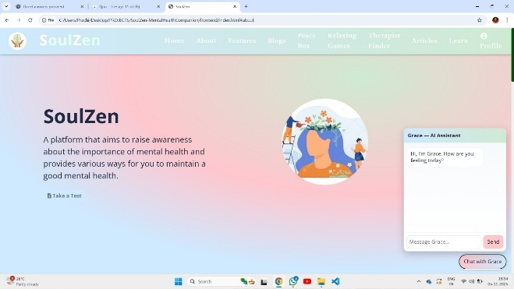
Fig 3.2 AI Therapist
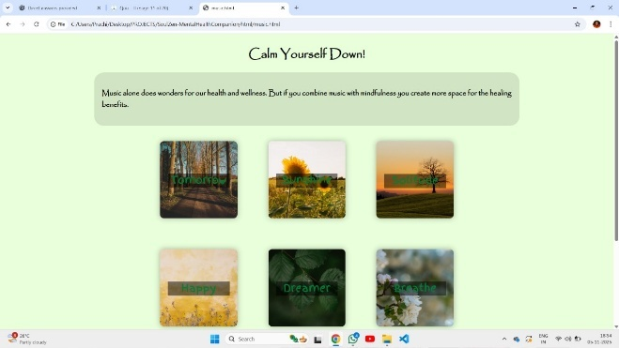
Fig 3.3 Peace Box
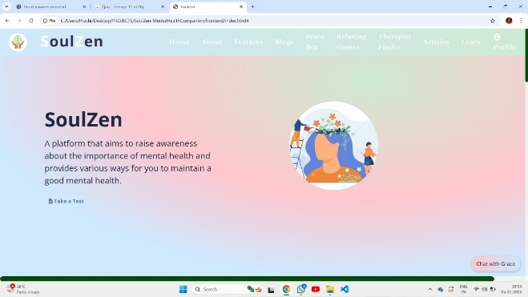
Fig 3.4 Home Page

IV. Conclusions

This paper presents a CNN based triage support system built for offline use in environments where infrastructure cannot be assumed. The classifier takes vital signs and symptom data as input and outputs a severity label, reducing the manual assessment step that slows prioritization under load. Results surface through a dashboard designed for use under pressure. The architecture is deliberately lean and runs on standard hardware without modification.
A few directions are worth pursuing from here. Adding multimodal inputs — wound images, wearable sensor streams, voice recordings — would give the classifier more to work with and improve accuracy on cases where vitals alone are ambiguous. Explainability tooling would let clinicians trace why the model reached a particular decision, which matters for trust and for catching errors before they affect patient care. Moving from SQLite to a cloud backed or hybrid database would support larger deployments and make it possible to update the model as new clinical data comes in. IoT integration and continuous learning are the logical next steps, but only after the offline core has been tested and validated in actual field conditions.

References

1] I. J. Goodfellow, Y. Bengio, and A. Courville, "Deep Learning," MIT Press, 2016.
[2] E. J. Topol, "High-performance medicine: the convergence of human and artificial intelligence," Nature Medicine, vol. 25, no. 1, pp. 44–56, 2019.
[3] M. Sendak et al., "A path for translation of machine learning products into healthcare delivery," EMJ Innovations, vol. 3, no. 1, pp. 28–35, 2019.
[4] D. Rajkomar, J. Dean, and I. Kohane, "Machine Learning in Medicine," New England Journal of Medicine, vol. 380, no. 14, pp. 1347–1358, 2019.
[5] S. Raita et al., "Emergency department triage prediction of clinical outcomes using machine learning models," Critical Care, vol. 23, no. 1, pp. 1–13, 2019.
[6] H. Chen, Y. Zhang, M. Kalra, F. Lin, and G. Liao, "Low-dose CT with a residual encoder-decoder convolutional neural network," IEEE Trans. Medical Imaging, vol. 36, no. 12, pp. 2524–2535, 2017.
[7] A. Esteva et al., "A guide to deep learning in healthcare," Nature Medicine, vol. 25, no. 1, pp. 24–29, 2019.
[8] K. He, X. Zhang, S. Ren, and J. Sun, "Deep Residual Learning for Image Recognition," in Proc. IEEE Conf. Comput. Vis. Pattern Recognit. (CVPR), 2016, pp. 770–778.
[9] T. Davenport and R. Kalakota, "The potential for artificial intelligence in healthcare," Future Healthcare Journal, vol. 6, no. 2, pp. 94–98, 2019.
[10] J. Gulshan et al., "Development and validation of a deep learning algorithm for detection of diabetic retinopathy," JAMA, vol. 316, no. 22, pp. 2402–2410, 2016.
[11] R. Miotto, F. Wang, S. Wang, X. Jiang, and J. T. Dudley, "Deep learning for healthcare: review, opportunities and challenges," Briefings in Bioinformatics, vol. 19, no. 6, pp. 1236–1246, 2018.
[12] A. Rajpurkar et al., "CheXNet: Radiologist-level pneumonia detection on chest X-rays with deep learning," arXiv preprint arXiv:1711.05225, 2017.
[13] Z. Obermeyer and E. J. Emanuel, "Predicting the future — big data, machine learning, and clinical medicine," New England Journal of Medicine, vol. 375, no. 13, pp. 1216–1219, 2016.
[14] M. A. P. Mahajan, R. Raina, and A. Gupta, "Exploring the limits of weakly supervised pretraining," in Proc. European Conf. Computer Vision (ECCV), 2018.
[15] J. Wiens and E. S. Shenoy, "Machine learning for healthcare: on the verge of a major shift in healthcare epidemiology," Clinical Infectious Diseases, vol. 66, no. 1, pp. 149–153, 2018.
[16] S. Biswal et al., "MINA: Multilevel knowledge-guided attention for modeling electrocardiography signals," in Proc. Int. Conf. Learning Representations (ICLR), 2018.
[17] N. Shickel, P. J. Tighe, A. Bihorac, and P. Rashidi, "Deep EHR: A survey of recent advances in deep learning techniques for electronic health record analysis," IEEE Journal of Biomedical and Health Informatics, vol. 22, no. 5, pp. 1589–1604, 2018.
[18] M. Esteva, B. Kuprel, and R. A. Novoa, "Dermatologist-level classification of skin cancer with deep neural networks," Nature, vol. 542, no. 7639, pp. 115–118, 2017.
[19] H. Liang et al., "Evaluation and accurate diagnoses of pediatric diseases using artificial intelligence," Nature Medicine, vol. 25, no. 3, pp. 433–438, 2019.

[20] Y. Liu et al., "A comparison of deep learning performance against health-care professionals in detecting diseases from medical imaging," The Lancet Digital Health, vol. 1, no. 6, pp. e271–e297, 2019.

